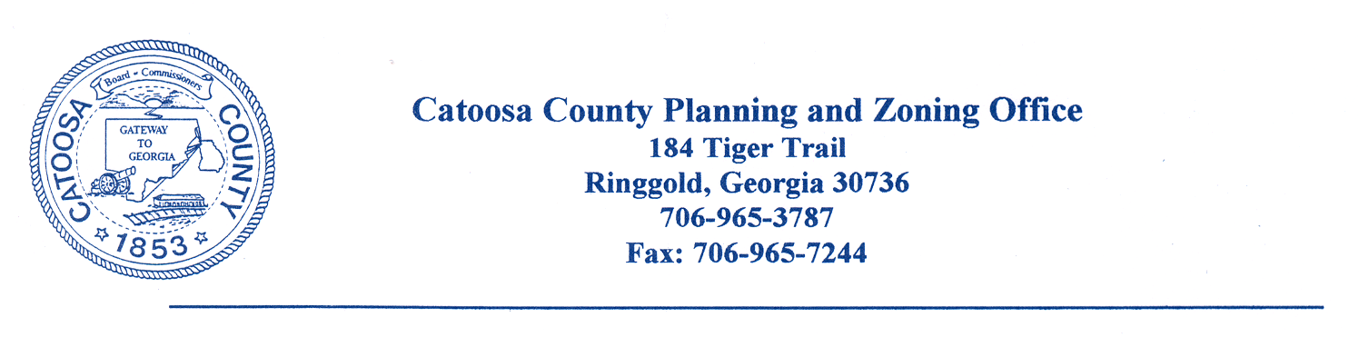
CATOOSA COUNTY ALCOHOL BEVERAGE COMMISSION
AGENDA FOR AUGUST 18, 2020

The Catoosa County Alcohol Beverage Commission will meet at the Catoosa County Administrative Building in Ringgold on Tuesday, August 18, 2020 @ 8:30 a.m.

- Call to Order

- Minutes Approval

- Reports

- Old Business

- New Business
Hugh Harris
Farm To Fork
Concession Stand for Alcohol Sales
745 Scruggs Road
Ringgold, GA 30736
Brainerd Motorsport

- Open Session

- Adjournment

cc: Catoosa County Board of Commissioners
Catoosa County Alcoholic Beverage Commission
Alicia Vaughn, County Manager
James Davis, Zoning Administrator
Chad Young, Attorney
Major Kelly Holcomb
Catoosa County Administration Building

