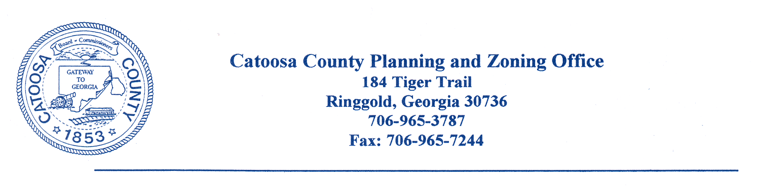
CATOOSA COUNTY PLANNING COMMISSION
AGENDA FOR JUNE 25, 2024, ZONING MEETING

REVISED AGENDA

The Catoosa County Planning Commission will meet at the Catoosa County Administration Building in Ringgold on Tuesday, June 25, 2024, at 6:00 p.m. for zoning approvals.

Case No. Applicant Name Tax/Parcel Location Request_________

1586-24 Josh Jeffery 00800018 Lake Rd. C-1 to R-1
00800017 Lake Rd. C-1 to R-1

1587-24 K3A Properties, LLC 0011C064 Mack Smith Rd. R-1 to C-1

NOTICE IS HEREBY GIVEN THAT A QUORUM OF THE CATOOSA COUNTY BOARD OF COMMISSIONERS MAY BE IN ATTENDANCE AT MEETINGS/WORKSESSIONS

CC: Catoosa County Board of Commissioners
Planning Commission Members
Dan Wright, County Manager
James Davis, Director of Planning and Inspections
Chad Young, Attorney
Catoosa County Administration Building
Jeremy Bryson, Transportation

