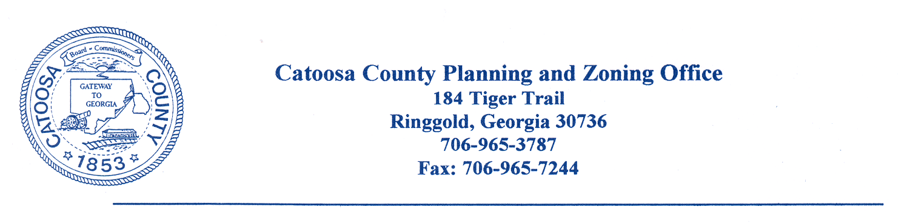
CATOOSA COUNTY ALCOHOL BEVERAGE COMMISSION
AGENDA FOR TUESDAY, FEBRUARY 20, 2024

The Catoosa County Alcohol Beverage Commission will meet at the Catoosa County Building Inspection/Zoning Building in Ringgold on Tuesday, February 20, 2024 @ 8:30 a.m.

- Call to Order
- Invocation
- Minutes Approval

- Reports

- Old Business

- New Business
GOVINDA TRADERS, INC
548 BOYNTON DRIVE
RINGGOLD, GA 30736
NEW STORE

- Open Session

- Adjournment

cc: Catoosa County Board of Commissioners
Catoosa County Alcoholic Beverage Commission
Dan Wright, County Manager
James Davis, Zoning Administrator
Chad Young, Attorney
Major Kelly Holcomb
Catoosa County Administration Building

