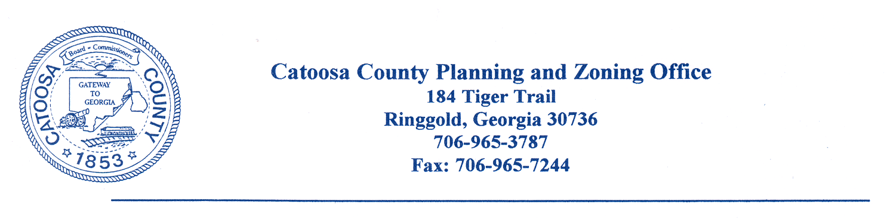
CATOOSA COUNTY PLANNING COMMISSION
AGENDA FOR JANUARY 24, 2023, ZONING MEETING

The Catoosa County Planning Commission will meet at the Catoosa County Administration Building in Ringgold on Tuesday, January 24, 2023, at 6:00 p.m. for zoning approvals.

Case No. Applicant Name Tax/Parcel Location Request_________

#1421-22 Paul A. Cox part of 2117 Three Notch C-2 to PUD
00230044 Road

#1422-23 James Newell 0001A047 943 Lakeview Dr R-1 to C-1

#1423-23 Down South Homes 0010B047, 1044 Scruggs C-1 & A-1
0019A003, 0019A00300A, to I-1
pt of 0019A004

#1424-23 Down South Homes 0010B047, 1044 Scruggs Variance
0019A003, 0019A00300A,
pt of 0019A004

#1425-23 David Sharp 0010A339 442 Prater Rd R-1 to C-1

#1426-23 David Sharp 0010A339 442 Prater Rd Variance

PUBLIC HEARING FOR PROPOSED CHANGES AND AMENDMENTS TO UDC

NOTICE IS HEREBY GIVEN THAT A QUORUM OF THE CATOOSA COUNTY BOARD OF COMMISSIONERS MAY BE IN ATTENDANCE AT MEETINGS/WORKSESSIONS

CC: Catoosa County Board of Commissioners
Planning Commission Members
Dan Wright, County Manager
James Davis, Director of Planning and Inspections
Chad Young, Attorney
Catoosa County Administration Building
Jeremy Bryson, Transportation

