REVISED
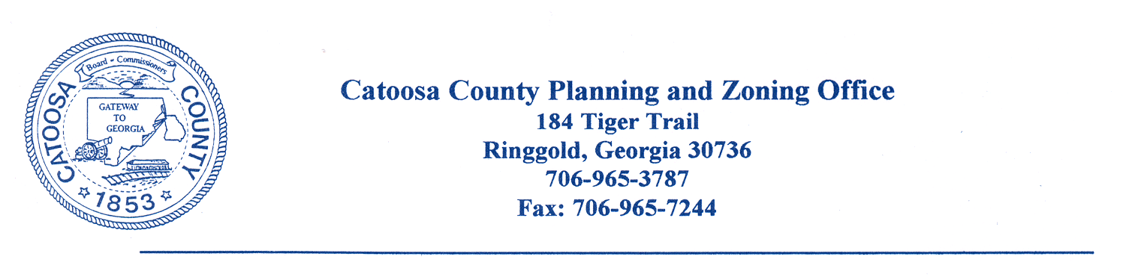
AGENDA

CATOOSA COUNTY PLANNING COMMISSION
AGENDA FOR OCTOBER 25, 2022, ZONING MEETING

The Catoosa County Planning Commission will meet at the Catoosa County Administration Building in Ringgold on Tuesday, October 25, 2022, at 6:00 p.m. for zoning approvals.

Case No. Applicant Name Tax/Parcel Location Request_________

#1413-22 Andrew Douglas Part of Salem Valley Rd A-1 to R-1
0073002500B

#1414-22 Better Built Homes LLC 0021B093 371 391 Foster Rd R-1 to C-R

#1415-22 Ray Leonard 00680018 12346 Hwy 41 C-1 to I-1

#1416-22 Ray Leonard 00680018 12346 Hwy 41 Special Use Permit

#1417-22 Michael Landers 0023A075 218 Old Mill Lane R-1 to C-1

NOTICE IS HEREBY GIVEN THAT A QUORUM OF THE CATOOSA COUNTY BOARD OF COMMISSIONERS MAY BE IN ATTENDANCE AT MEETINGS/WORKSESSIONS

CC: Catoosa County Board of Commissioners
Planning Commission Members
Dan Wright, County Manager
James Davis, Director of Planning and Inspections
Chad Young, Attorney
Catoosa County Administration Building
Jeremy Bryson, Transportation

