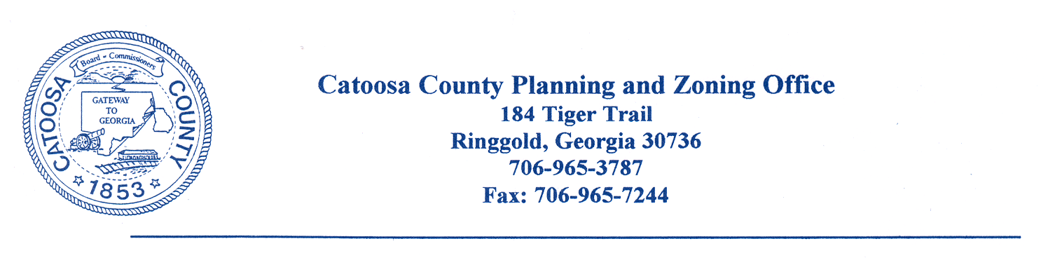
CATOOSA COUNTY ALCOHOL BEVERAGE COMMISSION
AGENDA FOR NOVEMBER 16, 2021

The Catoosa County Alcohol Beverage Commission will meet at the Catoosa County Administrative Building in Ringgold on Tuesday, November 16, 2021@ 8:30 a.m.

- Call to Order

- Minutes Approval

- Reports

- Old Business

- New Business
PATHIK PATEL
3240 BOYNTON DRIVE
RINGGOLD, GA 30736
NEW ALCOHOL

SHIKHA PATEL
125 PAGE ROAD
ROSSVILLE, GA 30741
NEW ALCOHOL

FARIDA VIRANI
438 HIGHWAY 41
RINGGOLD, GA 30736
CHANGE OF OWNERSHIP

- Open Session

- Adjournment

cc: Catoosa County Board of Commissioners
Catoosa County Alcoholic Beverage Commission
Dan Wright, County Manager
James Davis, Zoning Administrator
Chad Young, Attorney
Major Kelly Holcomb
Catoosa County Administration Building

